Lars van Duijnhoven
2 January 2025

Dear reader,

This is my motivation letter for studying abroad.
Here I will explain why I want to study abroad and why I have chosen the partners that I did.
Before all of that though, I will first introduce myself a bit.

Introduction

As you’ve probably already noticed, my name is Lars van Duijnhoven.
I’m currently studying Embedded Software Development at the HAN University of Applied Sciences. Furthermore, I’m 19 years old and I will be 20 when going abroad.
At the moment of writing (2 January 2025) I’m almost finished last school project, after which I will move on to my internship. After that I’ll be done with the thirth year and move on to fourth, which will start with my minor/ study abroad journey. This means I want to go abroad in the first semester of the study year 2025/2026.

Chosen partner universities
The universities are ranked from the most preferable to the less preferable option.

1. Häme University of Applied Sciences (HAMK), Hämeenlinna, Finland
My number one pick is the Häme University of Applied Sciences, which is located in Hämeenlinna, Finland. I chose this specific partner above all others in Finland, because this had study programs that I believe align with my study career, along with on-campus housing.
This is my top pick, because Finland seems so mysterious to me and I’d like to know more about it.
For example the culture, the people and the traditions (and I love snow). This is also represented in my current bucket list:
- Figuring out why there are so many sauna’s and why its such a regular thing. This includes having to experience various kinds myself.
- See the nordic lights.
- Experience rallying.
- Experience an ice racing circuit.
- Understand more about Finland as a country and its people, so it’s no longer a mystery.

2. Vorarlberg University of Applied Sciences, Dornbirn, Austria
Enough of Finland, let’s move on to my second pick, which is Vorarlberg University of Applied Sciences. This University is located in Dornbirn, Austria.
Just like my first pick, the study programs here were good and there was housing available for students who are studying abroad.
The thing about this is that it’s located in Austria, which is a country that I have been to multiple times. This means it isn’t as much of a mystery for me as Finland and that makes it less interesting to travel to (atleast for me). It is a beautiful country and that is the reason why its my second pick.

Financial Statement:
The screenshot below was taken from a spreadsheets document. This document can also be accessed via this link.
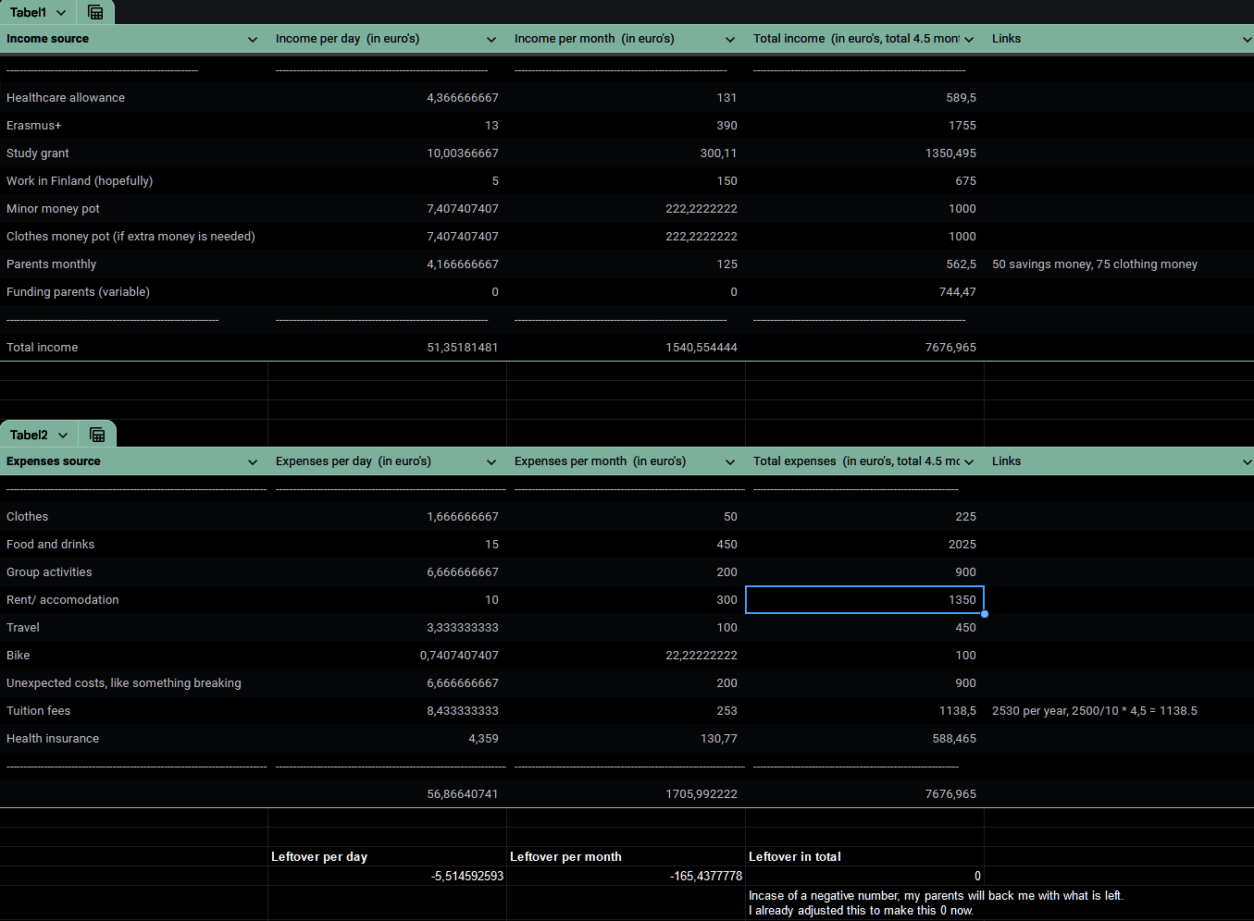
P.S. The daily income and expenses mostly consist of the monthly value divided by 30. This is why, for example, work shows up as 5 euro’s a day when in reality you only get it once a month.

I hope it’s possible for me to go abroad, because I think it will be a memory for me to never
forget. Not just because I have to do my own dishes and cook my own food, but also because of the opportunities and freedom I will have.

Yours sincerely,
Lars van Duijnhoven

